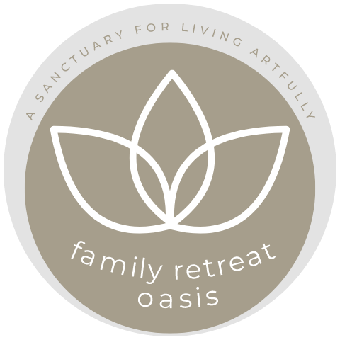

Family Retreat
Oasis

The clearer the boundaries the greater the expansion
To create a sacred, calm space for the mamas each morning we ask that no children are brought to the yoga shale or brunch table, so that all mothers can enjoy some childfree time.
We like to create a safe and sacred space for the children each morning. This means no mums in the childcare area (we offer some adaptation time on first day after introduction circle where mums can be present).
We invite mums to refrain from bringing their phones to yoga and meals. Try a tech-free morning and see how you relaxed you feel. Put away your phone two hours before bedtime. Please avoid media for the children in communal areas at all times.
Let’s move out of our comfort zones to make space for new ideas and refresh our beliefs.

With love and in service,
Evija and your Family Oasis Team

